PROJECT TITLE OVER HERE

SWE/156/23B

GERMAN-MALAYSIAN INSTITUTE

JANUARY 2025

PROJECT TITLE OVER HERE

SWE/156/23B

GROUP MEMBERS
AIN NURAIDA BINTI KHAIRULANUAR FIRHAN HARISH BIN MOHD FAIZAL
MUHAMMAD SYAHMI AFIF BIN MOHD SHAHRIRRUDDIN RAJAAHMAD AZFAR BIN RAJA BAHARUM

This project report is submitted as a partial fulfilment
of the requirement for the
Diploma in Software Engineering

PROJECT SUPERVISOR
MUHAMMAD AIDILSYUKRI BIN RADUAN

SOFTWARE ENGINEERING
COMPUTER & INFORMATION DEPARTMENT GERMAN-MALAYSIAN INSTITUTE

JANUARY 2025

1.0 Introduction 4
1.1 Project Background 4
1.2 Problem Statement 5
1.3 Project Objective 6
2.0 Literature Review 7
2.1 Feasibility Studies 8
3.0 Project Methodology 9
3.1 Principal of Operation 10
3.1.1 SDLC Process 12
3.1.2 Use Case Diagram 13
3.1.3 Use Case Specification 13
3.2 Project Specification 14
3.2.1 Software Specification 14
3.2.2 Hardware Specification 14
4.0 Testing Methodology 15
4.1 Testing Model 15
4.2 Testing Tools 16
5.0 Conclusion 17

1.0 Introduction

1.1 Project Background
Certificates are widely used by educational institutions, businesses, event organizers, and other organizations to recognize achievements, acknowledge participation, and confirm the completion of courses or activities. Preparing these certificates involves designing a suitable layout, entering recipient information, and producing documents for distribution or printing. When certificates must be generated for multiple recipients or recurring events, the ability to reuse designs and automate repetitive tasks can simplify the preparation process.
Existing design and document-editing applications can be used to create certificates, while spreadsheets and other data-management tools can store recipient information. However, users may need to combine several tools or repeat editing tasks to design certificates, manage recipient records, and generate personalized documents in batches. The effort involved depends on the tools and workflow being used, particularly when templates need to be reused or certificate information changes between events.
This project proposes the development of a web-based certificate generator using Flutter Web. The application will allow users to create certificate designs from scratch using layered elements or customize existing certificate backgrounds. Users will be able to position and format text, save reusable templates, and manage recipient information for future use. The system will support both manual data entry and CSV file imports, allowing recipient information to be applied to certificate templates for individual or batch generation. Generated certificates will be combined into a PDF document for convenient review, printing, and distribution. User accounts will allow templates and recipient data to be stored for subsequent use.

By integrating certificate design, template management, recipient data handling, and PDF generation into a single application, the project aims to provide a more streamlined workflow for producing personalized certificates. The system will focus on reducing repetitive editing, supporting template reuse, and maintaining consistent formatting across generated documents.

1.2 Problem Statement
Creating certificates for multiple recipients involves several related tasks, including preparing a design, entering recipient information, positioning text, and exporting the finished documents. When these tasks are performed separately or repeated for each recipient, the process can require unnecessary manual effort and introduce errors such as incorrect names, dates, or inconsistently positioned text. A workflow that applies recipient-specific information to a reusable certificate design could reduce the need to edit each document individually.
Another challenge is the reuse and management of certificate templates and recipient records. Users who prepare certificates for different events may need to locate existing designs, modify layouts, and retrieve previously used recipient information. When these resources are managed across separate files or applications, users may need to repeat work that could otherwise be reused. A centralized system for storing templates and recipient data could simplify this process and provide a more organized way to prepare certificates for recurring activities.
Generating personalized certificates for large groups also requires a reliable method of associating recipient information with the correct fields in a certificate design. Entering details individually can become inefficient as the number of recipients increases. Importing structured data from CSV files and automatically applying it to reusable templates offers an alternative to manually editing each certificate. However, the generated documents must preserve the intended text positioning and formatting, while allowing multiple certificates to be produced in a consistent PDF output.

1.3 Project Objective

- To develop a web-based certificate generator that allows users to create and customize certificate designs using layered elements and reusable templates.

- To implement a centralized management system for storing and reusing certificate templates and recipient information through user accounts and persistent data storage.

- To develop an individual and batch certificate generation function that supports manual data entry and CSV imports, producing consistently formatted certificates in PDF format.

2.0 Literature Review

This chapter reviews existing approaches, technologies, and systems related to certificate generation. It provides an overview of how certificates are designed, personalized, and generated using digital tools, with particular attention to template customization, recipient data management, and automated PDF generation. Existing applications and development technologies are considered to identify relevant features, limitations, and opportunities for developing the proposed certificate generator.
The review focuses on existing certificate creation workflows and the technologies required to implement a web-based system that supports reusable templates, manual data entry, CSV imports, and batch certificate generation. The findings from this chapter will provide a foundation for the system design and development by establishing the relevant concepts and technical considerations for the proposed project.

JUST DO IT AND SEE IF SIR ACCEPTS IT
NO GOOGLE FORM SO I ASSUME JUST RESEARCH LIKE ARTICLES/PAPERS OR COMPETITORS EXAMPLE
alterantiveto.com batch generate certificate, comparison between batch certificate generators

2.1 Feasibility Studies

3.0 Project Methodology
(Refer to Discord under #text-sv -> Sharifah Nina -> Chapter 3)

3.1 Principal of Operation
The web-based certificate generator operates by allowing users to create, customize, and generate personalized certificates through a graphical user interface. The application is designed to simplify certificate production by combining certificate design, recipient data management, and PDF generation within a single platform accessible through a web browser.
When the application is launched, users can log in to access their saved certificate templates and recipient data. Users can create a new certificate design from scratch using layered elements or upload an existing certificate background for customization. The application provides controls for positioning and formatting text elements, allowing users to arrange certificate details such as recipient names, event titles, dates, and other relevant information.
Once a certificate template has been prepared, users can save it for future use. Recipient information can be entered manually or imported from a CSV file containing multiple records. The system processes the supplied data and associates the relevant information with the corresponding fields in the selected certificate template. This allows users to generate certificates individually or produce multiple personalized certificates through a batch-generation process.
During certificate generation, the application applies the recipient information to the selected template while preserving the intended layout and text formatting. The generated certificates are then combined into a PDF document, allowing users to review the results and print or distribute the certificates as required. By integrating template customization, recipient data management, and automated document generation, the system aims to reduce repetitive manual editing and improve consistency across multiple certificates.

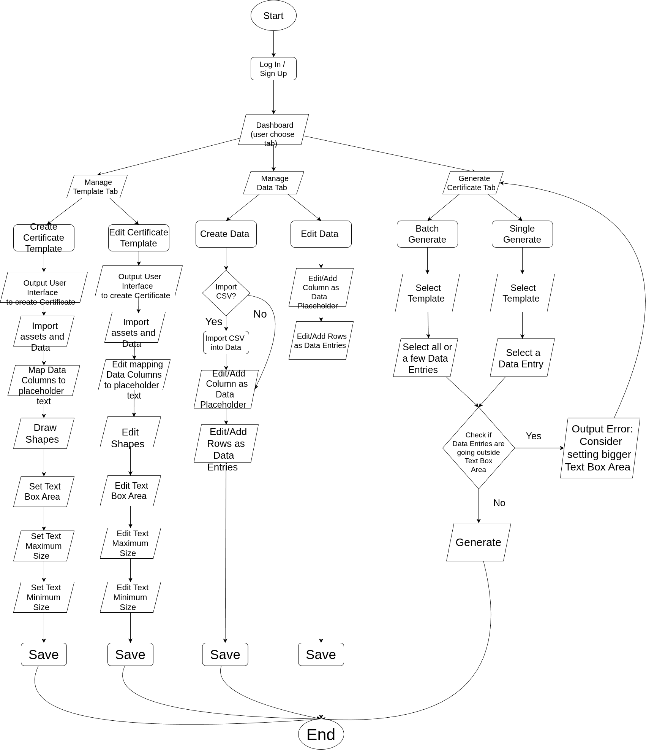
Figure ?.? Overall System Flow

3.1.1 SDLC Process
For this project, the Throwaway Prototyping methodology is selected as the System Development Life Cycle (SDLC) model. This approach allows technical features to be tested before finalizing the system design, reducing development risks associated with layered certificate editing, CSV data processing, and PDF generation.
During the Planning and Requirements Analysis phase, the system requirements are identified, including template customization, user authentication, recipient data management, and individual and batch certificate generation.
Next, during the Prototype Design and Construction phase, temporary prototypes are developed to test specific functions, such as text positioning, layered design elements, CSV imports, and PDF generation.
In the Prototype Evaluation phase, these prototypes are tested to identify technical issues and verify that the features operate as intended. The findings are then used to refine the final system design.
Finally, during the Final System Design and Implementation phase, the temporary prototypes are discarded, and the lessons learned are applied to develop the final application using Flutter Web and a suitable self-hosted backend. The completed system is then tested to verify its functionality.
This methodology helps resolve technical uncertainties early and provides a structured approach to developing the certificate generator and its supporting software engineering documentation.

3.1.2 Use Case Diagram
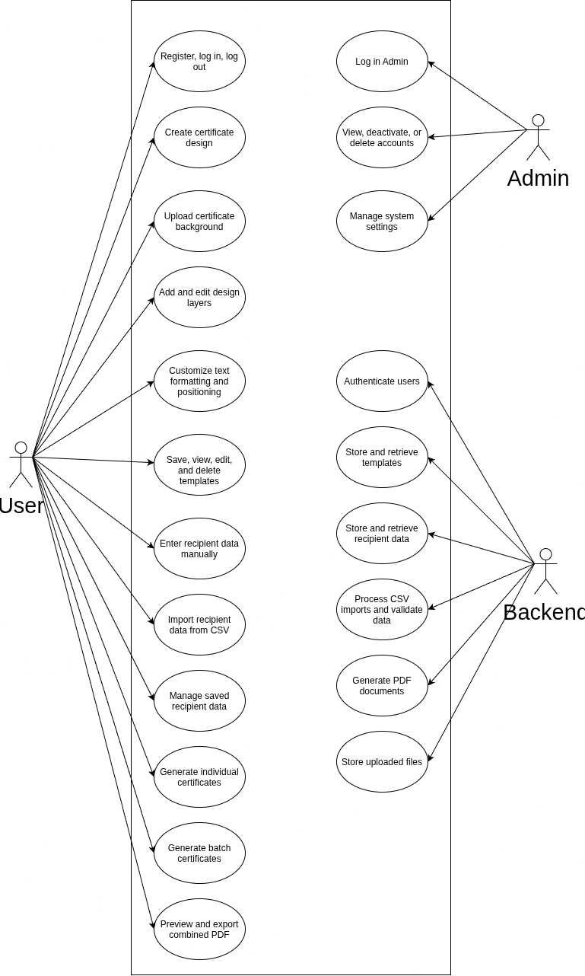

3.1.3 Use Case Specification

UC01: User Login
Item | Description
Primary Actor | Student / User
Preconditions | The user has a registered account.
Main Flow | 1. The user opens the application.  2. The system displays the login interface.  3. The user enters their email and password.  4. The system validates the credentials.  5. The system authenticates the user.  6. The system displays the user's dashboard.
Alternative Flow | If the credentials are invalid, the system displays an error and prompts the user to try again. If the user has no account, they can proceed to registration.
Postconditions | The user is authenticated and can access saved templates and recipient data.

UC02: Create Certificate Design
Item | Description
Primary Actor | Student / User
Preconditions | The user is logged in.
Main Flow | 1. The user selects the option to create a certificate.  2. The system displays the certificate editor.  3. The user creates a design from scratch or uploads an existing certificate background.  4. The system displays the design canvas.  5. The user adds text elements and adjusts their position and formatting.  6. The system updates the design preview.  7. The user saves the design as a template.  8. The system stores the template.
Alternative Flow | If the uploaded background is unsupported or invalid, the system displays an error. If the user exits without saving, the latest changes are not saved.
Postconditions | A certificate design is created and can be saved for future use.

UC03: Manage Certificate Templates
Item | Description
Primary Actor | Student / User
Preconditions | The user is logged in.
Main Flow | 1. The user opens the template management interface.  2. The system displays saved templates.  3. The user selects a template.  4. The system displays the selected template.  5. The user edits, reuses, or deletes the template.  6. The system performs the selected operation.  7. The system updates the template list.
Alternative Flow | If no templates exist, the system displays an empty state and an option to create one. If a template cannot be retrieved, the system displays an error.
Postconditions | The selected template is created, updated, retrieved, or deleted.

UC04: Manage Recipient Data
Item | Description
Primary Actor | Student / User
Preconditions | The user is logged in.
Main Flow | 1. The user opens recipient data management.  2. The system displays saved recipient records.  3. The user adds, edits, or deletes recipient information.  4. The user enters or updates recipient details.  5. The system validates the information.  6. The system saves the changes.  7. The system displays the updated records.
Alternative Flow | If required information is missing or invalid, the system prompts the user to correct it. If the user cancels, unsaved changes are discarded.
Postconditions | Recipient records are stored and available for future certificate generation.

UC05: Import Recipient Data from CSV
Item | Description
Primary Actor | Student / User
Preconditions | The user is logged in and has a CSV file containing recipient information.
Main Flow | 1. The user selects CSV import.  2. The system prompts the user to upload a file.  3. The user selects and uploads the CSV file.  4. The system reads the CSV headers and records.  5. The system displays available fields for mapping.  6. The user maps CSV columns to recipient fields.  7. The system validates the data.  8. The system displays a preview of the records.  9. The user confirms the import.  10. The system saves valid recipient records.
Alternative Flow | If the file is unsupported or unreadable, the system displays an error. If required fields are missing or values are invalid, the system identifies affected records. If the user cancels, the import is not committed.
Postconditions | Valid recipient records are imported and available for certificate generation.

UC06: Generate Individual Certificate
Item | Description
Primary Actor | Student / User
Preconditions | The user is logged in and has a certificate template and recipient information.
Main Flow | 1. The user selects a certificate template.  2. The system displays the template.  3. The user selects or enters recipient information.  4. The system validates the information.  5. The system inserts recipient details into the corresponding template fields.  6. The system generates a certificate preview.  7. The user reviews the certificate.  8. The user exports the certificate as a PDF.  9. The system provides the generated PDF.
Alternative Flow | If required recipient information is missing, the system prompts the user to provide it. If PDF generation fails, the system displays an error.
Postconditions | A personalized certificate is generated and available for preview or PDF export.

UC07: Generate Batch Certificates
Item | Description
Primary Actor | Student / User
Preconditions | The user is logged in and has a certificate template and recipient records.
Main Flow | 1. The user selects a certificate template.  2. The user selects a saved dataset or imports a CSV file.  3. The system validates the recipient records and field mappings.  4. The system displays a data preview.  5. The user confirms batch generation.  6. The system applies each recipient's information to the template.  7. The system generates a certificate for each valid record.  8. The system combines the certificates into one PDF document.  9. The system displays the generated PDF.  10. The user exports the PDF.
Alternative Flow | If records are invalid, the system identifies the affected records. If no valid records remain, generation is prevented. If PDF generation fails, the system displays an error.
Postconditions | A PDF containing multiple personalized certificates is generated.

UC08: Preview and Export PDF
Item | Description
Primary Actor | Student / User
Preconditions | At least one certificate has been generated.
Main Flow | 1. The system displays the generated PDF.  2. The user reviews the certificate pages.  3. The user selects the required pages, if page selection is supported.  4. The user chooses to export or print the document.  5. The system provides the PDF for download or opens the browser's print interface.
Alternative Flow | If the PDF cannot be generated or loaded, the system displays an error. If the selected page range is invalid, the system prompts the user to correct it.
Postconditions | The user can review, export, or print the generated PDF.

UC09: Manage User Accounts
Item | Description
Primary Actor | Admin
Preconditions | The administrator is authenticated and has the required permissions.
Main Flow | 1. The administrator opens the administrative interface.  2. The system displays user account management.  3. The administrator searches for or selects an account.  4. The system displays the account information.  5. The administrator selects an action, such as deactivating or deleting the account.  6. The system requests confirmation.  7. The administrator confirms the action.  8. The system applies the change and displays the updated status.
Alternative Flow | If the administrator lacks permission or the account cannot be found, the system displays an error. If the administrator cancels, no changes are made.
Postconditions | The selected user account is managed according to the administrator's action.

UC10: Authenticate and Store Application Data
Item | Description
Primary Actor | Backend Service
Preconditions | The application sends a request to the backend service.
Main Flow | 1. The application sends an authentication or data request.  2. The backend verifies the user's identity and permissions where required.  3. The backend validates the request.  4. The backend retrieves or stores templates, recipient records, or uploaded files.  5. The backend returns the result to the application.  6. The application displays the result.
Alternative Flow | If authentication fails, permissions are insufficient, or validation fails, the backend rejects the request. If storage or the service is unavailable, the application displays an error.
Postconditions | The requested authentication or data operation is completed, or an appropriate error is returned.

3.2 Project Specification

3.2.1 Software Specification
Software | Version | Justification
Chromium Browser | Latest stable | Runs the Flutter Web application and supports certificate preview, file uploads, and PDF downloads.
Flutter SDK | Stable release | Used to develop the web application's user interface and application logic.
Dart SDK | Version bundled with Flutter | Used to implement the application's logic and data processing.
Visual Studio Code | Latest stable | Provides a development environment for writing, debugging, and maintaining the source code.
Supabase | Stable self-hosted release | Provides authentication, database services, and file storage for user accounts, certificate templates, and recipient records.
PostgreSQL | Version supported by the selected Supabase release | Stores structured application data, including user-related records, templates, and recipient information.
Git | Latest stable | Tracks source code changes and supports version control during development.
Table ?.? List of Software

3.2.2 Hardware Specification

Hardware Minimum Requirements
CPU | Dual-core 64-bit processor, 2.0 GHz or equivalent
RAM | 4 GB
Drive Storage | 10 GB of available storage for development tools, project files, and dependencies
Operating System | Windows 10 or later, Linux, or macOS with compatible development tools
Additional Notes | A modern web browser and an internet or local network connection to access the application and backend services. A stable connection is required when using a remotely hosted backend.
Table ?.? List of Hardware

4.0 Testing Methodology

4.1 Testing Model

4.2 Testing Tools

5.0 Conclusion

